**DISCRETE MATHEMATICS (4 credits)**

Lecturer: Don Tasman, S.Mia, S.E, S.Si, S.S, M.M (D1805)





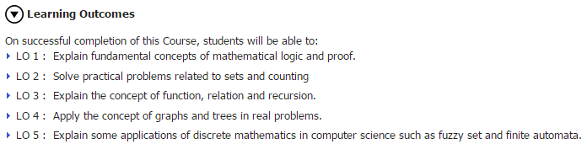



**LOGIC COMPOUND STATEMENTS**

A statement: a sentence that is TRUE or FALSE but not BOTH.

Ex:

2 + 3 = 5, √16 = 4, 7 is a prime number.

These are not statements: Close the door!, What’s your name?, x + 3 = 5.

**Negation:** ¬ or ~

Ex:

If p: 2 is a prime number (T) then ~p = ¬p : 2 is not a prime number (F).

If p: 2 > 6 (F) then ~p = ¬p : 2 ≤ 6 (T).

The truth table:

|  |  |
| --- | --- |
|  |  |
| 1 | 0 |
| 0 | 1 |

Set theory?

**Conjunction:** ∧

|  |  |  |
| --- | --- | --- |
|  |  |  |
| 1 | 1 | 1 |
| 1 | 0 | 0 |
| 0 | 1 | 0 |
| 0 | 0 | 0 |

Set theory?

Ex:

If p: 4 is a square number, q: 5 is odd, then p∧q? True or False?

If p: 2log 16 = 4, q: 23 = 5, then p∧q? True or False?

If p: 3 + 4 = 5, q: log 10 = 1, then p∧q? True or False?

If p: 3, 4 and 6 are Pythagorean numbers, q: Medan is lying in Java island, then p∧q? True or False?

**Disjunction:** ∨

|  |  |  |
| --- | --- | --- |
|  |  |  |
| 1 | 1 | 1 |
| 1 | 0 | 1 |
| 0 | 1 | 1 |
| 0 | 0 | 0 |

Set theory?

Ex:

If p: Cube root of 8 is 2, q: 4 is even, then p∨q? True or False?

If p: 35 = 243, q: 3log 81= 5, then p∨q? True or False?

If p: 3 × 4 = 7, q: ln e = 1, then p∨q? True or False?

If p: Pyramids are in India, q: Borobudur is in Kalimantan, then p∨q? True or False?

**Implication/Conditional: →**

|  |  |  |
| --- | --- | --- |
|  |  |  |
| 1 | 1 | 1 |
| 1 | 0 | 0 |
| 0 | 1 | 1 |
| 0 | 0 | 1 |

How to memorize this rule?

Set theory?

**Biimplication/Biconditional: ↔**

|  |  |  |
| --- | --- | --- |
|  |  |  |
| 1 | 1 | 1 |
| 1 | 0 | 0 |
| 0 | 1 | 0 |
| 0 | 0 | 1 |

How to memorize this rule?

Set theory?

**Implication, Converse, Inverse and Contrapositive**

Implication: p→q

Inverse: ¬p → ¬q

Converse: q → p

Contrapositive: ¬q → ¬p

**Make the truth table and notice the similarity!**

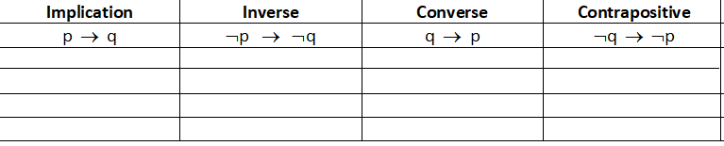

Ex: If he passes his exam then he will get a new bike.

Find the inverse, converse, contrapositive.

Exercise:

Build the truth table for:

[(p → q) ∧ (¬q ∨ r)] ↔ (p → r)

**Logical Equivalence**

Two statements P and Q are logically equivalence if they have identical truth values for every equal possibility.

1. p → q ≡ ¬p ∨ q ≡ ¬q → ¬p
2. p ↔ q ≡ (p → q) ∧ (q → p)
3. ¬(¬p) ≡ p
4. ¬(p ∧ q) ≡ ¬p ∨ ¬q
5. ¬(p ∨ q) ≡ ¬p ∧ ¬q
6. ¬ (p → q) ≡ p ∧ ¬q
7. ¬ (p ↔ q) ≡ (¬p ↔ q) ≡ (p ↔ ¬q)
8. Converse ≡ inverse, implication ≡ contrapositive

**Algebra of Proposition**

1. Idempotent rule: p ∨ p ≡ p, p ∧ p ≡ p
2. Associative rule: (p ∨ q) ∨ r ≡ p ∨ (q ∨ r); (p ∧ q) ∧ r ≡ p ∧ (q ∧ r)
3. Commutative rule: p ∨ q ≡ q ∨ p, p ∧ q ≡ q ∧ p
4. Distributive rule: p ∨ (q ∧ r) ≡ (p ∨ q) ∧ (p ∨ r); p ∧ (q ∨ r) ≡ (p ∧ q) ∨ (p ∧ r)
5. Identity rule: p ∨ F ≡ p, p ∧ T ≡ p, p ∨ T ≡ T, p ∧ F ≡ F
6. Complement rule: p ∨ ~p ≡ T, p ∧ ~p ≡ F, ~(~p) ≡ p, ~T ≡F, ~F ≡ T
7. De Morgan’s rule: ~(p ∨ q) ≡ ~p ∧ ~q, ~(p ∧ q) ≡ ~p ∨ ~q

**Simplifying Statements**

Simplify: ~(~p ∨ q) ∨ (p ∧ q)

**Tautology and Contradiction**

Tautology = a statement which is always true.

Contradiction = a statement which is always false.

Contingency = a statement which is not tautology and not contradiction.

Ex: [(p → q) ∧ (¬q ∨ r)] → (p → r)



**Valid and Invalid Argument**

**An argument** is a sequence of statements (or proposition). All statements (or proposition) in an argument except for the final one, are called **premises** (or assumptions or hypotheses). The final statement or statement form is called the **conclusion**. An **argument is valid** means that if the resulting premises are all true, then the conclusion is also true; otherwise it is invalid.

Ex:

1. 2.

 

**Rules of Inference**

1. Modus Ponens:



1. Modus Tollens



1. Syllogism (transitivity)



1. Elimination

 or 

1. Generalization

 or 

1. Specialization

 or 

1. Proof by division into classes



1. Contradiction



**Lukasiewicz Fuzzy Logic**

Lukasiewicz’s fuzzy logic is a logic form which has three values in the truth table, i.e. 1, ½ and 0.



|  |  |  |  |  |  |  |
| --- | --- | --- | --- | --- | --- | --- |
| **a** | **b** | **ā** | **∧** | **∨** | **→** | **↔** |
| 0 | 0 | 1 | 0 | 0 | 1 | 1 |
| 0 | ½ | 1 | 0 | ½ | 1 | ½ |
| 0 | 1 | 1 | 0 | 1 | 1 | 0 |
| ½ | 0 | ½ | 0 | ½ | ½ | ½ |
| ½ | ½ | ½ | ½ | ½ | 1 | 1 |
| ½ | 1 | ½ | ½ | 1 | 1 | ½ |
| 1 | 0 | 0 | 0 | 1 | 0 | 0 |
| 1 | ½ | 0 | ½ | 1 | ½ | ½ |
| 1 | 1 | 0 | 1 | 1 | 1 | 1 |

**Switching Circuits**

Draw p ∧ q and p ∨ q in switching circuits.

Verify when will the current flow!

Draw: {(p ∧ q) ∨ (q ∨ r)} ∧ p

Put in symbol:

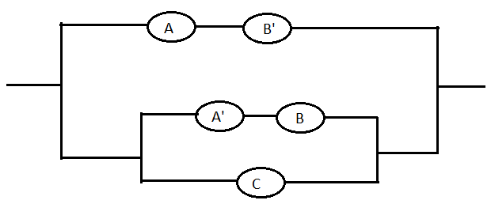

**GATES**

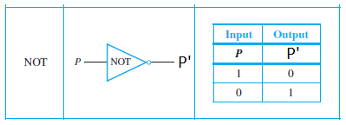

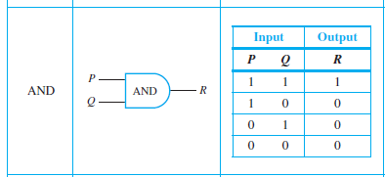

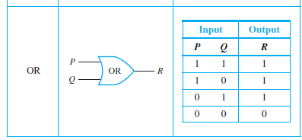

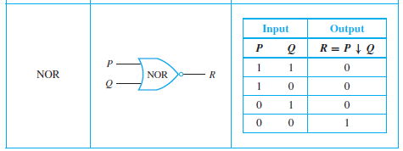

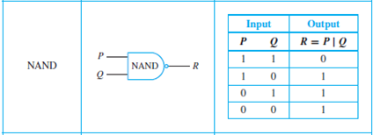

Ex: Put in symbol

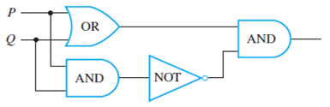

Example: Draw the following circuit (gates):

1. X=AB + C + D
2. X=A’+AB+B’(C+D)

State the symbol:

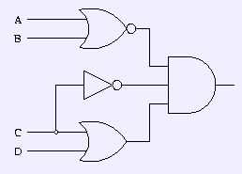

**KARNAUGH MAP**

The Karnaugh map, also known as the K-map, is a method to simplify boolean algebra expressions.

Two variables:

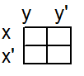

Ex: a. xy+xy’

b. xy+x’y+x’y’

c. xy+x’y’

Three variables:

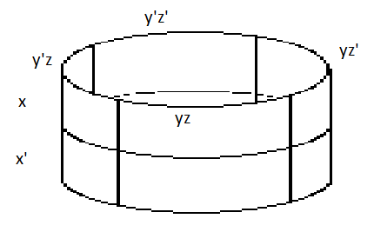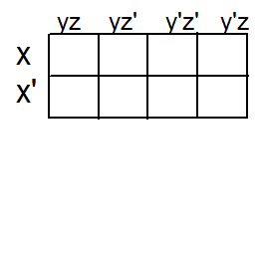

Ex: xyz+xyz’+xy’z+x’yz+x’y’z

Four variables:

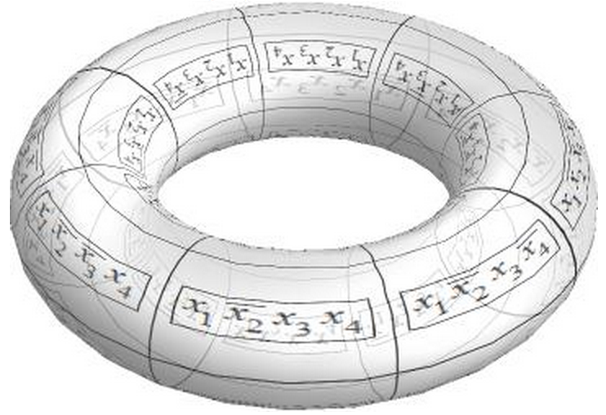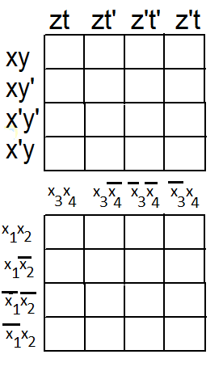

Ex: xyzt+xyz’t+xy’zt’+x’y’zt+x’y’zt’+x’y’z’t’+x’y’z’t+x’yzt+x’yz’t

Exercise:

1. Make the truth table: [(¬p∨q) ∧ (q → r)] → (¬p∨r)
2. Is no 1 a tautology, contradiction or contingency? Explain.
3. Determine whether the following argument is valid or invalid.

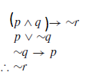

1. Determine whether the following argument is valid or invalid.

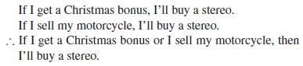

1. Determine whether the following argument is valid or invalid.

p → q

r ∨ s

~s → ~t

~q ∨ s

~s

~p ∧ r → u

w ∨ t

∴ u ∧ w

1. Write the logical symbol of the following.

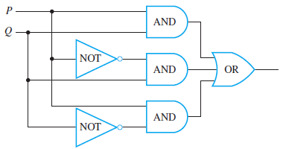

1. Design the gate circuit of X = PQR + PQ’R + PQ’R’

Can it be simplified? Explain.

1. Do the truth table of the following fuzzy logic:

(p ∧ q) → ¬p, if each p and q can take the values of 0, ½, 1.

**THE LOGIC OF QUANTIFIED STATEMENT**

A **predicate** is a sentence that contains a finite number of variables and becomes a statement when specific values are substituted for the variables.

Ex: P(x): x2 > x.

**The Universal Quantifier: ∀**

The symbol ∀ denotes “for all” and is called the universal quantifier. For example, another way to express the sentence “All human beings are mortal” is to write “∀ human beings x, x is mortal”.

A universal statement is a statement of the form “∀x ∈ D, Q(x).” It is defined to be true if, and only if, Q(x) is **true for every x in D**. It is defined to be false if, and only if, Q(x) is **false** for **at least one x in D**. A value for x for which Q(x) is false is called a **counterexample** to the universal statement.

Ex: Consider the statement ∀x ∈ R, x2 ≥ x. Find a counterexample to show that this statement is false.

**The Existential Quantifier: ∃**

The symbol ∃ denotes “there exists” and is called the existential quantifier. For example, the sentence “There is a student whose height is 150 cm” can be written as “∃p ∈ P such that p is a student whose height is 150 cm”.

Let Q(x) be a predicate and D the domain of x. An existential statement is a statement of the form “∃x ∈ D such that Q(x).” It is defined to be **true** if, and only if, Q(x) is true for **at least one x in D**. It is **false** if, and only if, Q(x) is **false for all x in D**.

Ex: Consider the statement ∃m ∈ Z+ such that m2 = m. Show that this statement is true.

Ex: Let A = {5, 6, 7, 8} and consider the statement ∃m ∈ A such that m2 = m. Show that this statement is false.

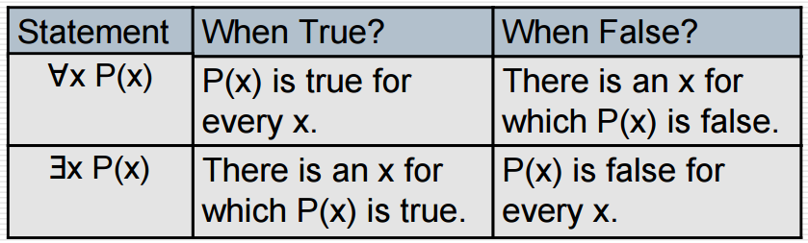

**Using a Diagram to Show Validity**

Ex:

State true or false:

1. All human beings are mortal.

Zeus is not mortal.

∴ Zeus is not a human being.

2. All human beings are mortal.

“A” is mortal.

∴ “A” is a human being.

**Negations of Quantified Statements**

∼[∀x ∈ D, Q(x)] ≡ ∃x ∈ D such that ∼Q(x).

∼[∃x ∈ D such that Q(x)] ≡ ∀x ∈ D,∼Q(x).

Ex: What is the negation of “Some students are lazy”?

Ex: What is the negation of “All top students are weird”?

Ex: Find the negation of “If the lecturer does not come then all students are happy”.

Ex: Find the negation of “If it rains heavily then some students cannot go home”.

**Multiple Quantifiers**

* ∀ **x** ∀ **y P(x,y)**

P(x,y) true for all x, y.

* ∃ **x** ∃ **y P(x,y)**

P(x,y) true for at least one x, at least one y.

* ∀ **x** ∃ **y P(x,y)**

For every value of x we can find one y so that P(x,y) is true.

* ∃ **x** ∀ **y P(x,y)**

For at least one x and for every y, P(x,y) is always true.

Ex: State true or false:

1. ∀x ∈ Z, ∃ y ∈ Z, x+y=17.

2. ∃y ∈ Z, ∀ x ∈ Z, x+y=17.

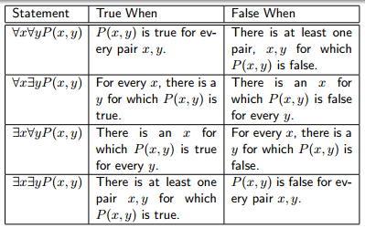

Ex:

Find the negation of:

∀ε>0, ∃δ>0, ∀x [(0 < ⏐x – a⏐ < δ) → (⏐f(x) – L⏐ < ε)]

**Exercise**

1. Write the symbol X = ….

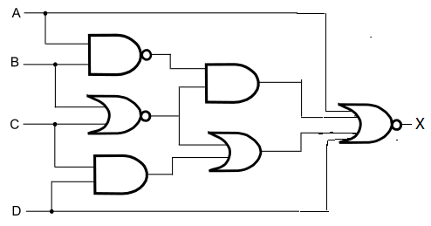

2. a. Draw: f = abc + ab’c + abc’

b. Using Karnaugh’s map, simplify the logic gate

c. Draw the simpler logic gate

3. Simplify E = xy + xy’

4. Simplify E = x’yz + xy’z + xyz’ + xyz.

5. Simplify E=xyzt + xyz’t + x’yzt + x’yz’t.

6. a. True or false ∀x ∈R , x4 > x ? Find the negation.

b. True or false ∃ x ∈ R, x2 = 2 ? Find the negation.

7. a. ∀x∈R ∃y ∈ R, x + y = 10. True or false?

b. ∃y∈R ∀x ∈ R, x + y = 10. True or false?

c. Is 7a equivalent to 7b?

8. If the domain is real numbers, determine the truth value of:

a. ∀x∀y ∃z, x + y = z.

b. ∃z ∀x∀y, x + y = z.

c. Is 8a equivalent to 8b?

9. Find the negation of:

a. ∃x ∀y ∃z, F(x,y,z) ∧ G(x,y,z)

b. ∃x ∀y ∃z, F(x,y,z) → G(x,y,z)

c. ∃x ∀y ∃z, F(x,y,z) ↔ G(x,y,z)

10. Find the negation of:

∀ε>0, ∃δ>0, If then 